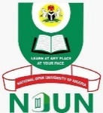

NATIONAL OPEN UNIVERSITY OF NIGERIA

SERVICE CHARTER

SERVICOM UNIT
OFFICE OF THE VICE-CHANCELLOR

© National Open University of Nigeria
Headquarters
Plot 91, University Village
Nnamdi Azikiwe Expressway
Airport Road
Jabi, Abuja

Lagos Liaison Office
14/16, Ahmadu Bello Way
Victoria Island
Lagos.

Published By
National Open University of Nigeria
Email: enquiries@nou.edu.ng, centralinfo@noun.edu.ng
URL: www.nouonline.net

Published 2025

ISBN 978-978-786-380-0

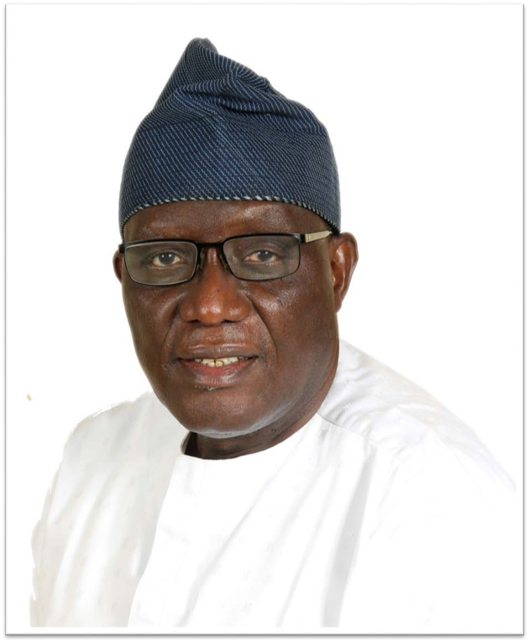

PROF. OLUFEMI A. PETERS
Vice-Chancellor

PRINCIPAL OFFICERS

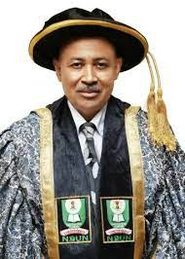

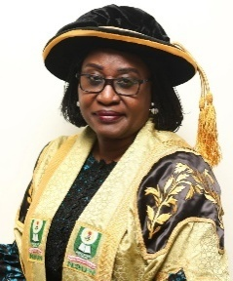
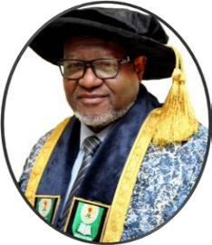

Prof. Shehu Usman Adamu
DVC, Administration

Prof. Christine Ofulue
DVC TIR

Prof. Chiedu Mafiana
DVC, Academic
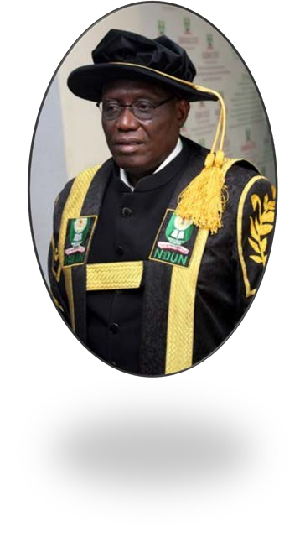

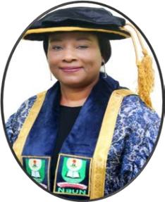
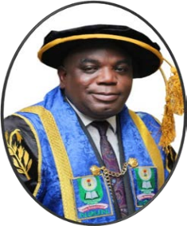
Prof. Olufemi Peters
Vice-Chancellor

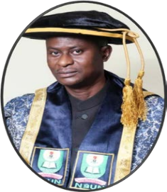

Prof. Angela E. Okpala
University Librarian
Mr. Oladipo Ajayi
Registrar

Mr. Nasiru Marafa
Bursar
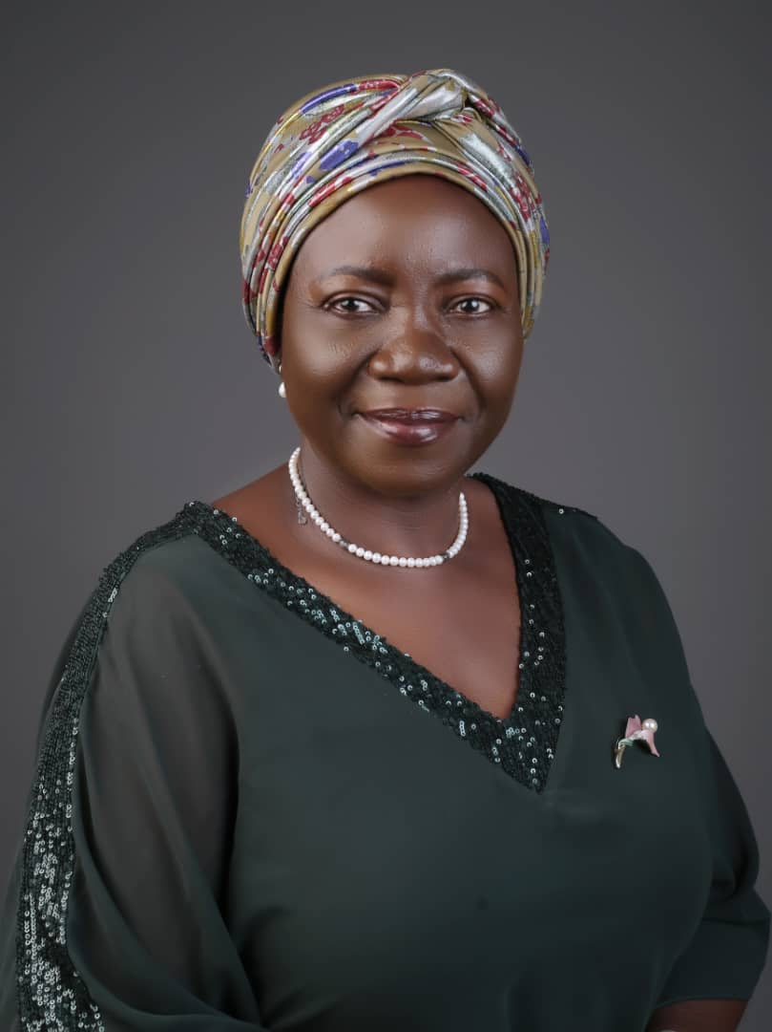

MRS. FOLUKE ADENIRAN
Nodal Officer/SERVICOM Unit Head

SAY NO TO SERVICE FAILURE

VISION

To be regarded as the foremost University providing highly accessible and enhanced quality education anchored by social justice, equality, and national cohesion through a comprehensive reach that transcends all barriers.

MISSION

To provide functional, cost-effective, and flexible learning that adds lifelong value to quality education for all who seek knowledge.

National Open University of Nigeria Service Charter
September 2025

FOREWORD

The need to integrate new experiences and improve on what currently exists in service delivery has become paramount for SERVICE COMPACT, a government creative response towards improving service delivery at the workplace. We believe this endeavour is a mission possible.

The National Open University of Nigeria (NOUN) is strongly committed to applying best practices in service delivery. In demonstration of this, NOUN has a very proactive SERVICOM Unit and was the first educational institution to prepare and publish the SERVICE CHARTER in April 2014. Since then, the University has grown in structure and service delivery, hence this third edition of the SERVICE CHARTER.

The SERVICE CHARTER constitutes an expectation that service delivery would greatly improve if new approaches and strategies were put into practice in the workplace. NOUN SERVICE CHARTER, while enumerating mandates and highlighting clients’ expectations, also seeks to emphasise complaints and redress mechanisms within the university.

While I confidently urge our clients and other stakeholders to avail themselves of this Charter, may I stress that we deeply dedicate ourselves to providing services through best practices above and beyond to all who seek knowledge in a timely, transparent, effective, effective, honest, and courteous manner.

It is hoped that all our stakeholders, through the Charter, will continue to access our services better than hitherto.

Prof. Olufemi A. Peters
Vice-Chancellor
CONTENTS
Principal Officers iv
Say No To Service Failure vi
Foreword vii
Organisational Structure of the University x

Chapter One 1
1.0 Background 1
1.1 Purpose of Service Charter 2

Chapter Two 4
2.0 Details of Service Provision/Delivery 4
2.1 Noun Services 4
2.2 Academic/Vocational Programmes 7
2.3 Methods of Course Delivery 8

Chapter Three 9
3.0 Lists of Customers/Clientele (Inter, Intra,
And Public) 9
3.1 Special Needs Provision 9
3.2 Noun Information and Call Centre (NICC) 9
3.3 Duration of Academic Programmes &
Time Frame 11

Chapter Four 12
4.0 Details of Grievances Redress Mechanism 12

Chapter Five 15
5.0 Obligations and Expectations 15
5.1 Expected Outcomes 15
5.2 Customer 16
5.3 Monitoring of Performance 17
5.4 Noun Collaborations with Other Institutions 17
5.4.1 National Level 17
5.4.2 International Development Partners 18
5.5 Limitations 23
5.6 Review of Charter 23

Names and Addresses Of Study Centres 28
Academic Programmes in the University 59

ORGANISATIONAL STRUCTURE OF THE UNIVERSITY
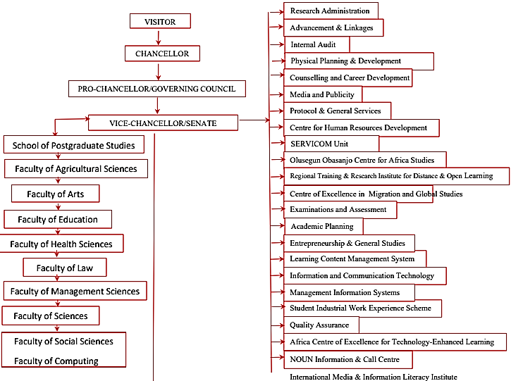

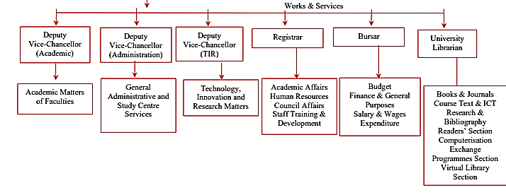

CHAPTER ONE

1.0 BACKGROUND

The National Open University of Nigeria (NOUN) was initially established on 22nd July 1983 as a springboard for open and distance learning in Nigeria, but was suspended on 25th April 1984. However, in recognition of its tremendous role in tackling the country’s educational problems/needs and providing access to education for all, it was resuscitated in the year 2002.

NOUN was designed to increase the access of all Nigerians to formal and non-formal education in a manner convenient to their circumstances. It was also to cater for the continuous educational development of professionals such as Teachers, Accountants, Bankers, Lawyers, Nurses, Engineers, Politicians, Self-employed, Businessmen and Businesswomen, etcetera. The range of target clientele is wide and shall be continually reviewed to meet Nigeria’s ever-changing needs.

With its Headquarters moved from Victoria Island, Lagos, to University Village, 91, Cadastral Zone, off Airport Expressway, Jabi, Abuja. NOUN currently has 123 Study Centres and formations covering 36 states of the federation and the Federal Capital Territory (FCT), Abuja.

A Service Charter is a written document that outlines the services that institutions provide and the standard of service that the customers/clients can expect.

1.1 PURPOSE OF SERVICE CHARTER

The SERVICOM Charter is a framework designed to improve public service delivery in the National Open University of Nigeria (NOUN). Its key purposes include:

- Enhanced Service Delivery: Ensuring efficient, timely, and satisfactory service delivery.
- Increased Accountability: Holding NOUN and its staff accountable for their service delivery.
- Citizen-Centric Approach: Prioritising the needs and expectations of citizens as customers.
- Clear Service Standards: Setting specific benchmarks for service quality and performance.
- Continuous Improvement: Promoting a culture of ongoing improvement in service delivery.
- Performance Monitoring and Evaluation: Regularly assessing service delivery and taking corrective action.
- Strengthened Government-Citizen Relationship: Building trust through transparency and accountability.
- Effective Complaint Handling: Providing a mechanism for citizens to voice concerns and seek redress.

1.2 VISION

To be regarded as the foremost University providing highly accessible and enhanced quality education anchored by social justice, equity, equality, and national cohesion through a comprehensive reach that transcends all barriers.

1.3 MISSION

To provide functional, cost-effective, flexible learning which adds lifelong value to quality education for all who seek knowledge.

1.4 OBJECTIVES

In addition to the broad vision and mission statements above, some of the major objectives of the National Open University of Nigeria are to:

- Ensure equity and equality of opportunities in education generally, but specifically, in university education
- Provide a wider access to education generally, but specifically to university education in Nigeria
- Enhance Education for All and lifelong learning
- Provide the entrenchment of global culture
- Provide educational resources via intensive use of information and communication technologies
- Provide flexible but qualitative education
- Reduce the cost, inconveniences and hassles of education delivery.

CHAPTER TWO

2.0 DETAILS OF SERVICE PROVISION/DELIVERY

2.1 NOUN Services

NOUN offers a variety of services, which include but are not limited to the following:

S/N | SERVICES | PROCESSES | DELIVERY STANDARD  TIME COST |  | DEPARTMENT
1 | Admission | Apply online via www.nou.edu.ng  www.nouonline.nou.edu.ng | Immediately after admission | N 20,000 (PhD)  N7,500 (PGD, MSc)  N5,000 (UG) | Registry
2 | Academic transcripts, Credit transfers, Letter of proficiency | Apply online via www.transcript.nou.edu.ng | 2 weeks after request | Varies on location | Academic Registry, SPGS
3 | Course Materials | Download via www.nou.edu.ng |  | Free
4 | Tutor-Marked Assignments (TMAs) | Visit www.elearn.nou.edu.ng |  |  | Directorate of Examination and Assessment
5 | Facilitations | Visit www.elearn.nou.edu.ng |  | Free | Learning Content Management System
6 | Counseling Services | Visit Study Centres | Mon - Fri | Free | Directorate of Counselling & Career Development
7 | Library Services | Visit Study Centres/ Headquarters |  | Free | University Library
8 | IT Support | Visit Study Centres/ Headquarters | 24 hours | Free | Directorate of ICT
9 | Certificate Issuance | Visit Study Centres/ Headquarters |  |  | Academic Registry
10 | Course Registration | Visit www.nouonline.nou.edu.ng | 24 hours | As stipulated in the fees | Directorate of MIS
11 | Entrepreneurship Programmes | Visit www.deags.nou.edu.ng |  |  | Directorate of Entrepreneurship & General Studies
12 | Release Examination Results | Visit www.nouonline.nou.edu.ng | 1st Senate meeting after exams |  | Senate
13 | Change of Course | Visit the Academic Registry/Apply on the student portal. www.nouonline.nou.edu.ng | Within 1 week | N5,000 | Academic Registry
14 | Change of Study Centre | Apply on the student portal. www.nouonline.nou.edu.ng | Within 3 days | Free | Directorate of Counselling & Career Development
15 | Students Complaints | Visit www.support.nou.edu.ng | 24 hours | Free | NICC
16 | Students Account | Visit Study Centres/ Headquarters | Working hours | Free | Bursary
17 | Examination timetable | Visit www.nou.edu.ng | Semesterly | Free | Directorate of Examination and Assessment
18 | Academic Calendar | Visit www.nou.edu.ng | Annually | Free | Directorate of Academic Planning
19 | Student Orientation | Visit www.nou.edu.ng | Semesterly | Free | Registry

2.2 ACADEMIC/VOCATIONAL PROGRAMMES

At the National Open University of Nigeria, we offer the following programmes:

- Certificate Programmes. These are courses that last between six months to one academic year. They are mainly sub-degree programmes and, in some cases, could qualify candidates for enrolment into diploma programmes. There are some other certificate courses which, when completed, will not qualify one for a higher enrolment. These are called Proficiency Certificate Courses. The Centre for Lifelong Learning offers most of these certificate courses.
- Diploma Programmes. Diploma programmes run for a minimum of two academic years. They are also sub-degree programmes. Diplomas, too, could be taken in a full-time mode or in a flexible mode. To qualify to proceed to the appropriate degree programmes of NOUN, holders of Diploma Certificate would be required to make up any deficiencies in their SSCE, GCE, NECO, NABTEB, and T.C.II
- First Degree Programmes. These are programmes that lead to the award of first degrees in given disciplines. Students carry the load according to their ability, capability, availability of time, and their financial situation.
- Higher Degree Programmes. These are programmes you register for after a first degree. It could be at the diploma level, the master's Level, or the doctoral level. Some first-degree holders may be required to possess a post-graduate diploma to qualify them for admission into master’s programmes in the University.
These academic programmes are offered in nine faculties, excluding vocational courses at the Centre for Lifelong Learning. The faculties are as follows:

- Faculty of Arts
- Faculty of Social Sciences
- Faculty of Education
- Faculty of Law
- Faculty of Management Sciences
- Faculty of Science
- Faculty of Computing
- Faculty of Health Sciences
- Faculty of Agricultural Sciences

2.3 METHODS OF COURSE DELIVERY

NOUN shall provide instructional learning materials through any or a combination of the following:
- Printed materials
- CD-ROMS
- VCD, DVD
- Audio tapes
- Radio
- Web-based delivery
- Occasional face-to-face tutorial sessions to facilitate learning
- Integrated workplace experience scheme (e.g. clinical attachment,
SIWES, teaching practice, internship, moot court, etc.).
- Excursions

CHAPTER THREE

3.0 LISTS OF CUSTOMERS/CLIENTELE (INTER, INTRA, AND PUBLIC)

NOUN renders services to all who seek knowledge, including the young, old, employed, unemployed, prison inmates, those in Purdah, nomads, and the physically challenged. Customised programmes for organisations and communities who desire them are also considered.

3.1 SPECIAL NEEDS PROVISION

NOUN caters for all categories of its students, including the physically challenged. Course materials in Braille form and requisite computer software are made available to visually challenged students. Similarly, efforts are on to make the environment of NOUN (Headquarters and the Study Centres) more friendly and conducive for the physically challenged students. In addition, the University Management recently created a Unit, Learner Support for Special Needs (LSSN), under the Directorate of Learner Support Services. This Unit is responsible for providing adequate support to learners with Special Needs in NOUN. The importance of education for the above category of students is underscored by the fact that NOUN has many physically challenged individuals on its staff list.

3.2 NOUN INFORMATION AND CALL CENTRE (NICC)

The NOUN Information and Call Centre (NICC), formally known as the VICC, in conjunction with the E-ticketing platform, was established on June 7, 2022, by the Vice-Chancellor, Prof. Olufemi Peters. As the designated unit responsible for providing relevant and accurate information about the institution to all who engage with NOUN, the primary goal is to consistently uphold NOUN’s mission through exceptionally efficient service delivery, focusing on enhancing efficiency and effectively addressing learners’ inquiries and challenges.

NICC Support Platforms/Channels and Their Major Activities
The National Open University of Nigeria has established online support services for its learners through the NOUN Information and Call Centre (NICC). These services include providing learners with timely information, advice, and guidance on technical and admission support. Additionally, NICC facilitates academic advice from faculty and offers guidance and counselling through the Directorate of Learner Support Services (DLSS).

E-Ticket Platform
The concept of the E-ticketing platform, a paperless electronic document, aims to establish a significant learner support system to address queries from NOUN learners on any issue that relates to the essence of their studentship. The platform offers NOUN learners an efficient alternative to the time-consuming traditional methods for addressing their concerns. Tailored for NOUN students, this platform enables them to submit complaints or inquiries through support@nou.edu.ng, ensuring a swift response without the necessity of personally visiting the Study Centres or the Headquarters.

3.3 DURATION OF ACADEMIC PROGRAMMES & TIME FRAME

The flexibility of the NOUN mode of study allows a student to determine the pace, place, time, and mode of study. As an Open University student, you may choose to study at the exact programme duration or at your own pace. For instance:

Programmes Delivery Target
- Proficiency Certificate 1day to 3 months
- Certificate 3 months to 1 year, 2 years flexible mode
- Diploma 2 years, 4 years flexible mode
- First Degree (B.A., B.Ed., B.Sc.) 4 years, 8 years flexible mode
- Post Graduate Diploma 3 semesters, 2 to 3 years, flexible mode
- Master’s Degree (M.A., M.Ed., M.Sc.) 4 semesters maximum 2 to 3 years, flexible mode
- Doctor of Philosophy (Ph.D.) 3 years, 8 years maximum

CHAPTER FOUR

4.0 DETAILS OF GRIEVANCES REDRESS MECHANISM

Pertinent to the delivery of the vision and mission statements of NOUN is the right of the learner to seek redress when any of such services as contained in the statements fail to meet their expectations.

What can a person complain about?
A person may complain about any issue that the complainant believes affects his/her studies.

How does a person make a complaint?
If a person wants to complain about academic or related issues that affect him/her, the complainant could do so either by writing a letter, email, text messages, telephone, or face-to-face contact to the undermentioned in order of ascendancy starting from:

Step One

The Complaints Desk Officer: servicom@noun.edu.ng, 09027590739 or any SERVICOM Representative.

If the complainant is not satisfied, he/she can contact
The Nodal Officer/SERVICOM Unit Head: Mrs. Foluke Adeniran
Office of the Vice-Chancellor
National Open University of Nigeria
91, Cadastral Zone
University Village
Nnamdi Azikiwe Expressway
Jabi
Abuja
E-mail: servicom@noun.edu.ng
Phone No: 09027590739

If the complainant is still dissatisfied, they can contact

Step Two

The Vice-Chancellor
National Open University of Nigeria
91, Cadastral Zone
University Village
Nnamdi Azikiwe Expressway
Jabi
Abuja.
Email: vc@noun.edu.ng

If the complainant is not satisfactorily handled by Step Two, please contact:

Step Three

The National Universities Commission
Julius Okojie Building
No 26, Aguiyi Ironsi Street
Maitama District
P.M.B. 237, Garki G.P.O.
Abuja, Nigeria.
Email: nucservicom@nuc.edu.ng, nucservicom@gmail.com

If the complainant is still unsatisfied, he/she can contact:

Step Four

The SERVICOM Complaints Manager
SERVICOM Office (The Presidency)
Federal Secretariat, Phase III, First Floor
Abuja
Email: info@servicom.gov.ng

Alternative dispute resolutions and appeal mechanisms can be used in lodging complaints. In addition, complaints could be dropped in the Suggestion Boxes, submitted to the SERVICOM Office or SERVICOM Complaint Officer, telephone: 09027590739, e-mail: servicom@noun.edu.ng. Furthermore, a dedicated e-mail: centralinfo@nou.edu.ng is entirely for complaints and suggestions. In any case, the complainant is advised to be specific on the grievance.

CHAPTER FIVE

5.0 OBLIGATIONS AND EXPECTATIONS

At NOUN Study Centres, the Study Centre Directors represent the Vice-Chancellor in all things: the Directors and the other staff members are symbols of the University, who must be respected and honoured accordingly. During the contact periods, students should endeavour to keep strictly to the rules and regulations of the University and be guided by the Matriculation Oath taken.

5.1 EXPECTED OUTCOMES

It is expected that the National Open University of Nigeria will, among other things, do the following:

- Raise the literacy level in Nigeria;
- Substantially increase access to University education;
- Widen the catchment scope of beneficiaries of University education, thus reaching the hitherto unreachable and ensuring that nobody interested in
- and capable of having a university education, is left out;
- Help Nigerians to be on the right side of the digital divide;
- Enhance and facilitate workplace training and professional development; and
- Reduce the demand for admission placed on the conventional universities.

Customers are entitled to:
- Quality research and reports.
- Transparent admission procedure,
- Prompt attention to complaints
- Provision of relevant academic programmes
- Prompt release of examination results
- Prompt release of transcripts
- Efficacy on the part of our members of the Council, Staff, and students
- Transparent Performance Evaluation
- Library Facilities and Services,
- Prompt response to requests and enquiries,
- Good feedback and grievance redress mechanism,
- Prompt payment procedures.

5.2 CUSTOMER

Obligations/Responsibilities
To achieve our targets, our customers are expected to:
- Know and support our programmes and activities
- Present genuine credentials
- Adherence to rules and regulations
- Pay all approved fees
- Attend scheduled meetings punctually
- Punctuality to work
- Prompt discharge of duties and services
- Abstain from examination malpractices, alcohol, drug abuse, fighting, etc.
- Courtesy and respect for staff, students, and the public
- No littering of the University environment
- Dress neatly and officially
- Maintain cleanliness in the University environment
- Lawlessness to be reported to the University authority
- Staff and students to be treated with fairness
- Service failure, complaints, and feedback to be reported.

The University points are available 24 hours a day:
+2348038514090, +2349082907092, +2349056463036, +2348079917938 &
E-mail address: centralinfo@noun.edu.ng

5.3 MONITORING OF PERFORMANCE

- Monthly collation and analysis of complaints by SERVICOM Unit
- Quarterly meeting of SERVICOM Representatives
- Monthly reports from Study Centres
- Periodic assessment of staff performance
- Monitoring of examinations

5.4 NOUN COLLABORATIONS WITH OTHER INSTITUTIONS

NOUN maintains linkages and collaboration with various Institutions at both National and International levels, some of which are listed below in no particular order.

5.4.1 NATIONAL LEVEL

- National Universities Commission (NUC)
- Tertiary Education Trust Fund (TETFUND)
- Federal Ministry of Education (FME)
- Administrative Staff College of Nigeria (ASCON)
- Federal Radio Corporation of Nigeria FRCN)
- National Board for Technical Education (NBTE)
- National Commission for Colleges of Education (NCCE)
- Nigerian Communications Commission (NCC)
- National Youth Service Corps (NYSC)
- National Commission for Nomadic Education (NCNE)

5.4.2 INTERNATIONAL DEVELOPMENT PARTNERS

Members of the planning committee for the setting up of the National Open University of Ghana were hosted and inducted in July 2008 in NOUN.

NOUN has been chosen by NEPAD as the collaborating partner in the Training of Teachers using ODL for West African states.

At the international level, NOUN maintains links with many open and distance learning institutions, including the Open University of the United Kingdom, the Indira Gandhi National Open University, University of Southern Queensland, and the International Council for Distance Education. Particular mention must be made of the Open University of Hong Kong for the mentoring role to the university, especially at the commencement of operations in 2002.

As the University grows and more programmes are included in its offerings, other linkages will be explored for a variety of relationships for the benefit of both the students and the staff of NOUN.

It is important to state that the continuous faith our International Development partners, especially the Commonwealth of Learning (COL), have in the Nigerian project at NOUN has regularly become an impetus to our resolve to see our dreams come through at the National Open University of Nigeria. Such relationships are helpful to the NOUN. Some of these will be given a special mention here, given the scope and size of support received from them. The Commonwealth of Learning (COL) has continued to provide support for human capacity building, including 50 scholarships for M.Ed. in Distance Education through the Indira Gandhi National Open University of India. In addition, COL has sponsored many training workshops for staff of the University and has further provided the programmes on Legislative Drafting and Executive MBA/MPA respectively for NOUN to use as part of its programmes to be offered. Of special significance is the selection of NOUN by COL as a Regional Centre for Training and Development in Open and Distance Learning (RETRIDAL), now known as the Regional Training and Research Institute for Distance and Open Learning (RETRIDOL).

UNESCO is another collaborating body that has set up a special task force on education in Nigeria, and as part of this, Open and Distance Learning is receiving a lot of attention. As a result, NOUN has benefited from special support from UNESCO through the establishment of a professorial chair in Open and Distance Learning.

NOUN is also in collaboration with the Open University of Shanghai through the African Council for Distance Education (ACDE) on a staff and students exchange programme. There is also collaboration between Open Educational Resources (OER) and the United Nations Educational, Scientific and Cultural Organisation (UNESCO).

In all, the National Open University of Nigeria is set to make its own unique contributions to the development of Nigeria in general and to individual and group upliftment in particular.

Africa Centre of Excellence on Technology Enhanced Learning (ACETEL) is a World Bank-assisted project supported by the Association of African Universities and the National Universities Commission (NUC), Nigeria. The Centre focuses on the development of human capacity and research in digital solutions that will lead to the utilisation of technology for education and its development to other sectors. The centre hopes to bridge the technology knowledge gap by building capacity in Information Communication Technologies (ICTs), Cyber Security and Digital policies to achieve high levels of digital development on the African continent.

The Centre has a strong partnership base with national and international institutions and industries. These include: the Open University UK; the University of the West of England; Kwame Nkrumah University, Ghana; African Virtual University, Kenya; South African Institute for Distance Education; Ahmadu Bello University; Obafemi Awolowo University’s Centre for OAK; and the Nigerian Defence Academy. Industry partners include CISCO Nigeria, Softcom Nigeria, Glo Nigeria, MTN Nigeria, Natview Computers, ALT-I and IPI Solutions, as well as public sector partners such as the National Information Technology Development Agency (NITDA), the National Communications Commission (NCC), and the Abuja Technology Village, among others.

Alternative dispute resolutions and appeal mechanisms can be used in lodging complaints. In addition, complaints could be dropped in the Suggestion Boxes, submitted to the SERVICOM Office or SERVICOM Complaint Officer; telephone: 09027590739, e-mail: servicom@noun.edu.ng. Note that a dedicated e-mail, centralinfo@nou.edu.ng, is entirely for complaints and suggestions. In any case, the complainant is advised to be specific about the grievance.

Other Stakeholders’ Participation

External Stakeholder Involvement in NOUN's Service Delivery

External stakeholders play a critical role in enhancing NOUN's service delivery. These stakeholders, including industry partners, alumni, donors, government agencies, professional bodies, and the community, contribute through various channels such as partnerships, funding, internships, and curriculum development.

Key Contributions of External Stakeholders:
- Industry Partnerships: Collaboration with industries to align curriculum with market needs, provide internship opportunities, and enhance graduate employability.
- Alumni Engagement: Offer mentorship, career guidance, financial support, and insights to shape teaching and research.
- Donor and Philanthropic Support: Provide financial resources for scholarships, research, infrastructure, and innovation.
- Government and Regulatory Oversight: Ensure quality standards, compliance with national education objectives, and provide funding.
- Professional Body Collaboration: Accredit courses, to ensure professional qualifications, and provide curriculum input.
- Community Involvement: Engage with the community through outreach programmes, research collaborations, and social responsibility initiatives.
- Research Partnerships: Advance knowledge through joint research projects, grants, and publications.

NOUN's Strategies for Regular Consultations:
- Advisory Boards and Committees: Establishing platforms for strategic guidance and programme evaluation.
- Periodic Surveys and Feedback Mechanisms: Gathering feedback from stakeholders to assess satisfaction and programme relevance.
- Industry-Academia Forums and Workshops: Fostering dialogue and collaboration between industry and academia.
- Memoranda of Understanding (MoUs): Formalising partnerships and outlining collaborative activities.
- Consultative Meetings: Discussing strategic plans, funding needs, and programme relevance with stakeholders.
- Public Lectures and Knowledge Exchange Programmes: Sharing knowledge and insights with external stakeholders.
- Employer Satisfaction Surveys: Assessing graduate performance and aligning programmes with industry demands.
- Accreditation and External Audits: Ensuring quality standards through external evaluation.

By actively engaging with external stakeholders, NOUN aims to improve the quality of its education and services, enhance the employability of its graduates, and contribute to societal development.

5.5 LIMITATIONS

NOUN, like other institutions, is also beset with some challenges to its operations, which are, but not limited to, the following;

- Activities of NOUN are ICT-based. Thus, the optimum performance of NOUN is dependent largely on the reliability of the Electricity Power Supply (EPS) and the functionality of NIGSATCOM.
- Inadequate and late release of funds by the government.

5.6 REVIEW OF CHARTER

The review process will occur periodically, often every two years. This is to ensure that the service delivery standards remain relevant, aligned with the NOUN objectives, and responsive to stakeholder needs.

Names Of Officials/Contact E-Mail Addresses
S/N | NAMES | PRINCIPAL OFFICERS | E-MAIL ADDRESS
1. | Prof. Olufemi Peters | Vice Chancellor | fpeters@noun.edu.ng
2. | Prof. Chiedu Mafiana | Deputy Vice-Chancellor: Academic | cmafiana@noun.edu.ng
3. | Prof. Shehu Usman Adamu | Deputy Vice Chancellor: Administration | suadamu@noun.edu.ng
4. | Prof. Christine Iyetunde Ofulue | Deputy Vice-Chancellor, Technology Innovation and Research | cofulue@noun.edu.ng
5. | Mr. Oladipo Ajayi | Registrar | aajayi@noun.edu.ng
6. | Mr. Nasir Marafa | Bursar | nmarafa@noun.edu.ng
7. | Prof. Angela Okpala | University Librarian | aokpala@noun.edu.ng

Deans/Directors/Unit Heads
S/N | NAMES | SCHOOLS/DIRECTORATES/  UNITS | E-MAIL ADDRESS
1. | Prof. Sonnie J. Oniye | School of Postgraduate Studies | sjoniye@noun.edu.ng
2. | Prof. Gideon Sunday Omachonu | Faculty of Arts | gsomachonu@noun.edu.ng
3 | Prof. Kamal Bello | Faculty of Social Sciences | kbello@noun.edu.ng
4 | Prof. Mustapha Momoh | Faculty of Management Sciences | mmomoh@noun.edu.ng
5 | Prof. Bamikole O. Ogunleye | Faculty of Education | bogunleye@noun.edu.ng
6 | Dr. Ishaya Martins | Faculty of Law | mishaya@noun.edu.ng
7 | Prof. Olayemi M. Olaniyi | Faculty of Computing | omolaniyi@noun.edu.mg
8 | Prof. Kolawole Lawal | Faculty of Science | kmlawal@noun.edu.ng
9 | Prof. Nda E. Mundi | Faculty of Agric. Sciences | mnda@noun.edu.ng
10 | Prof. Helen Kwanashie | Faculty of Health Sciences | hkwanashie@noun.edu.ng
11 | Prof. Dorothy Ofoha | RETRIDOL | dofoha@noun.edu.ng
12 | Prof. Olubiyi Adewale | Directorate of NOUN Press | oadewale@noun.edu.ng
13 | Prof. Olugbenga Ojo | Examinations & Assessments | oojo@noun.edu.ng
14 | Dr. Francis Osang | Information & Communication Technology | fosang@noun.edu.ng
15 | Dr. Lukuman Bello | Learning Content Management System | lbello@noun.edu.ng
16 | Prof. Juliet Iniegbedion | Quality Assurance | jinegbedion@noun.edu.ng
17 | Prof. Joy Eyisi | SIWES | jeyisi@noun.edu.ng
18 | Arc. Sadiq O. Shuaib | Physical Planning & Development | ssadiq@noun.edu.ng
19 | Mr. Ibrahim Sheme | Media and Information | isheme@noun.edu.ng
20 | Prof. Ganiyat Adesina-Uthman | Advancement and Linkages | oileka@noun.edu.ng
21 | Mr. Michael Falolu | Internal Audit | mfalolu@noun.edu.ng
22 | Ms. Dinah Dijah Abass | Procurement | dabbas@noun.edu.ng
23 | Daniel Bitrus Riki | Legal | danidirki2005@yahoo.com
24 | Barr. Fatai Lawal | Protocol services | Fatailawal2001@yahoo.com
25 | Mrs. Aionodion Wosilatu | NOUN Information and Call Centres | wainodion@noun.edu.ng
26 | Mrs. Adeniran Foluke | SERVICOM | fadeniran@noun.edu.ng
27 | Dr. Bridget Yakubu | Head, Course Material Development Unit | ayakubu@noun.edu.ng
28 | Prof. Gregory O. Okagbare | Director, Academic Planning | ookagbare@noun.edu.ng
29 | Arc. E.Akueshi | Ag. Director, Works & Services | eakueshi@noun.edu.ng
30 | Mrs. Doris Nzenwa | Head, Anti-Corruption and Transparency Unit | dnzenwa@noun.edu.ng
31 | Prof. S.M Ayodele | Director, Research Administration | sayodele@noun.edu.ng
32 | Prof. Willy Ugwuanyi | Director, Olusegun Obasanjo Centre for Africa Studies | wugwuanyi@noun.edu.ng
33 | Prof. Gloria Anetor | Director, Centre of Excellence in Migration and Global Studies | ganetor@noun.edu.ng
34 | Dr. Lateef Adelakun | Director, International Media and Information Literacy Institute | ladelakun@noun.edu.ng
35 | Prof. Grace Jokthan | Director, Africa Centre of Excellence for Technology-Enhanced Learning | gjokthan@noun.edu.ng
36 | Dr. Sefiya Omuya | Director, Directorate of Counselling & Career Development | somuya@noun.edu.ng
37 | Prof. Aminu Umar | Director, Centre for Human Resource Development | aminuumar@noun.edu.ng
38 | Mr. Adeyinka M. Adeboyejo | Director, Management Information System | aadeboyejo@noun.edu.ng
39 | Mrs. Eunice Riki | Director, Staff Training & Development | eriki@noun.edu.ng
40 | Dr. Samuel Awolumate | Director, Directorate of Entrepreneurship & General Studies | sawolumate@noun.edu.ng
41 | Dr.Hassan Mohammed | Head, University Clinic | mohammedhassan@noun.edu.ng
42 | Mrs. Medlyn Obieze | Head, Medical Diagnostic Laboratory | mokolo@noun.edu.ng
43 | Mr. Sule Onuh | Head, Software Development Unit | sonuh@noun.edu.ng
44 | Prof. Dorothy Ofoha | Head, ACDE-QAAA | dofoha@noun.edu.ng
45 | Olusegun Timothy Oladapo | Head, Printing Press | ooladapo@noun.edu.ng
46 | Mr. Napoleon Arubi | Head, Course Material Warehouse | narubi@noun.edu.ng
47 | Mr. Awe Umar Mohammed | Director, Security Services | umohammedu@noun.edu.ng
48 | Mr. Funso B. Odebode | Director, Budget & Planning | fodebode@noun.edu.ng
49 | Mr. Bola Petu | Director, Academic Registry | bpetu@noun.edu.ng
50 | Dr. Muyiwa Akintola | Director, Human Resources | makintola@noun.edu.ng
51 | Mr. Bolarinwa R. Feruke | Director, Accounts | rferuke@noun.edu.ng
52 | Mrs. Fadimatu Fufore Mohammed | Head, Council Unit | ffufore@noun.edu.ng
53 | Mr. Patrick Opara | Head, Store | popara@noun.edu.ng

NAMES AND ADDRESSES OF STUDY CENTRES

Information on the Study Centres as of July 2025
The University currently has 123 Study Centres which are in state capitals, major towns in all the six geo-political zones of the country as well as the Federal Capital Territory (Abuja). Some of these Centres have permanent NOUN structures, while others are situated within some selected Colleges of Education and Polytechnics. The Centres are grouped into categories. A recently approved administrative structure by the Council places the Centres into geopolitical zones for administrative convenience. Within each of the geopolitical zones, the categories of the different Centres are discernible. We have the State Study Centres, the Community Study Centres, the Special Correctional Centres, and the Special Study Centres. All State Study Centres are established by the University. The Community Study Centres are established by the community where they are situated. Special Study Centres are sited in the military and paramilitary formations, including Correctional Centres. The Centres provide an avenue for enhancing the economic development of the rural communities and alleviating poverty, as well as serve as viable avenues for Information and Communication Technology (ICT) penetration into the Nigerian society, which can raise the technological literacy of the communities.

At these Study Centres, students have access to professional counsellors whose job is to inform, advise, and guide them through their studies as long as they remain NOUN students. At the Centres, we also have physical facilitation rooms, an examination hall, an ICT hall, and a library. It is at the Study Centres that admissions into Departments are checked, course registrations are done, and study materials are collected. It is also at the Centres that students sit for their examinations.


NATIONAL OPEN UNIVERSITY OF NIGERIA
Directorate of Counselling & Career Development
Plot 91, Cadastral Zone, Nnamdi Azikwe Expressway, Jabi, Abuja Directory for Study Centres (2025)

GEO POLITICAL ZONE | S/N | STUDY CENTRE | FULL ADDRESS
NORTH EAST | 1 | BAUCHI STUDY CENTRE  Ag. Centre Director  Mrs. Hauwa E. Dede | Former NRC Building, Federal Low-Cost Housing  Estate, Bauchi, Bauchi State  edede@noun.edu.ng  08036178916
NORTH EAST | 2 | AZARE COMMUNITY STUDY CENTRE  Wuse  Ag. Centre Director | Azare Old Maiduguri – Kano Bye Pass, Off  Federal Low Cost Azare, Katagum LGA, Bauchi State  Yet to be appointed
NORTH EAST | 3 | BOGORO COMMUNITY STUDY CENTRE  Centre Director  Mr. Olumuyiwa Peter Akintola | Along Gobbiya Road, Marang Gwaranga, Bogoro LGA, Bauchi State  oakintola@noun.edu.ng july21pita@yahoo.com  08036131764
NORTH EAST | 4 | YOLA STUDY CENTRE  Ag. Centre Director  Mr. Olumide Aladuge | Army Barracks Road, Yola, Adamawa State  oaladuge@noun.edu.ng  08027470001
NORTH EAST | 5 | GULAK COMMUNITY STUDY CENTRE  Ag. Centre Director  Yamtu, John Margaret (Mrs.) | Mubi North Local Government Secretariat Mubi, Adamawa State  jyamtu@noun.edu.ng  07063234784
NORTH EAST | 6 | MAIDUGURI STUDY CENTRE  Centre Director  Dr. Buba Baba Shani | Baga Road, P.O. Box 548, Maiduguri- Mubi Express Way, Borno State  bshani@noun.edu.ng  08034574544
NORTH EAST | 7 | DAMATURU STUDY CENTRE  Centre Director  Dr. Muhammed A. Machina | Former Amusement Park, Maiduguri Road,  Damaturu, Yobe State  mmachina@noun.edu.ng,  08036148866
NORTH EAST | 8 | JALINGO STUDY CENTRE  Centre Director  Mr. Bala Lazarus | Education Resource Centre, Former T/C Staff Quarters Jalingo, Taraba State  lbala@noun.edu.ng  08036381639
NORTH EAST | 9 | WUKARI COMMUNITY STUDY CENTRE  Centre Director  Dr. Zira B. Wada | Former Local Government Lodge, Tsokundi Road, Wukari, Taraba State  zwada@noun.edu.ng,  08142739421, 08075859361
NORTH EAST | 10 | GOMBE STUDY CENTRE  Ag. Centre Director  Dr. Adamu Bappah | After All Saints College, Gombe Federal Low Cost, P.M.B 0163, Gombe, Gombe State  abappah@noun.edu.ng  08027061853
 | 11 | SORO COMMUNITY STUDY CENTRE  Ag. Director  Mrs, Hauwa Ezra Dede | Soro Community Bauchi State  edede@noun.edu.ng  08036178916
NORTH WEST | 12 | KANO STUDY CENTRE  Ag. Director  Mr. Ahmed M. Ishaq | Independence Road, Sauna-Dakata, Kano,  Kano State  mishaq@noun.edu.ng  08033551486
 | 13 | FAGGE COMMUNITY STUDY CENTRE FAGGE  Centre Director  Mal. Ibrahim Shehu | Katsina Road, Old Triumph Building Fagge Local Government Secretariat, Kano State  ibshehu@noun.edu.ng  08033903920
 | 14 | KWACHIRI COMMUNITY STUDY CENTRE  Rep. Study Centre  Dr. Ali Alassan | Rijiyar Lemo Beside Masama Stores Fagge Local Government Secretariat, Kano State  aalasan@noun.edu.ng  0909960125
 | 15 | KABO COMMUNITY STUDY CENTRE  Centre Director  Dr. Ahmad Abubakar Abdullahi | Kabo Local Government Secretariat, Kano State  aaamad@noun.edu.ng  08032853267
 | 16 | DAWAKIN KUDU COMMUNITY STUDY CENTRE  Centre Director  Dr. Ali Alasan | Dawaki Road, Dawakin Kudu Local Government, Kano State  aalasan@noun.edu.ng  09099601255
 | 17 | SHANONO COMMUNITY STUDY CENTRE  Centre Director  Dr. Ahmad Abubakar Abdullahi | Shanono Local Government Secretariat, Kano State  aaamad@noun.edu.ng  08032853267
 | 18 | BAGWAI COMMUNITY STUDY CENTRE  Centre Director | Behind Bagwai Local Government Secretariat, Kano State  Yet to be appointed
 | 19 | RIMIM-GADO COMMUNITY STUDY CENTRE  Centre Director  Dr. Ahmad Abubakar Abdullahi | Rimim-Gado Local Government Secretariat,  Kano State  aaahmad@noun.edu.ng  08032853267
 | 20 | DAWAKIN TOFA COMMUNITY STUDY CENTRE  Centre Director  Dr. Haliru Tijjani | Dawakin Tofa Local Government Secretariat,  Kano State  thalliru@noun.edu.ng  08034371016
 | 21 | TOFA COMMUNITY STUDY CENTRE  Centre Director | Behind Tofa Local Government Secretariat, Kano State  Yet to be appointed
 | 22 | BICHI COMMUNITY STUDY CENTRE  Ag. Centre Director | Behind Bichi Local Government Secretariat,  Kano State  Yet to be appointed
 | 23 | DANBATA COMMUNITY STUDY CENTRE  Centre Director | Danbata Local Government Secretariat, Kano State  Yet to be appointed
 | 24 | GWARZO COMMUNITY STUDY CENTRE  Centre Director  Dr. Ahmad Abubakar Abdullahi | Gwarzo Local Government Secretariat, Kano State  aaahmad@noun.edu.ng  08032853267
 | 25 | KUNCHI COMMUNITY STUDY CENTRE  Centre Director | Kunchi Local Government Secretariat, Kano State  Yet to be appointed
 | 26 | MAKODA COMMUNITY STUDY CENTRE  Ag. Centre Director | Makoda Local Government Secretariat, Kano State  Yet to be appointed
 | 27 | GABASAWA COMMUNITY STUDY CENTRE  Centre Director  Dr. Ali Alasan | Local Government Secretariat, Zakirai,  Gabassawa Local Government Area, Kano State  aalasan@noun.edu.ng  09099601255
 | 28 | TSANYAWA COMMUNITY STUDY CENTRE  Centre Director | Behind Tsanyawa Local Government Secretariat, Kano State  Yet to be appointed
 | 29 | DUTSE STUDY CENTRE  Centre Director  Dr. Ahmed Tanimu Mahmoud | 3rd Floor, Federal Government Secretatriat,  Kiyawa Road, Dutse, Jigawa State  amahmoud@noun.edu.ng  08038034912, 08029116172
 | 30 | HADEJIA COMMUNITY STUDY CENTRE  Study Centre Director  Dr. Ibrahim Garba Gwammaja | New GRA Extension, Behind Shagari Community School, Hadejia LGA, Jigawa State  igwammaja@noun.edu.ng  08038214674
 | 31 | GUSAU STUDY CENTRE  Ag. Centre Director  Mr. Surajo Haido Aliyu | A4, Commissioner’s Quarters, Bye-Pass,  Gusau, Zamfara State  saliyu@noun.edu.ng  08139602929 (WhatsApp) 07085756960
 | 32 | KADUNA STUDY CENTRE  Centre Director  Dr. Babagida Iro | Kaduna Campus (Old NETC) by Trade Fair Complex, KM 4 Zaria Road, Kaduna, Kaduna State  biro@noun.edu.ng  08033540469
 | 33 | SPECIAL STUDY CENTRE FOR THE NIGERIA AIRFORCE BASE KADUNA  Centre Director  Dr. Baba M. Galadima | 325 Ground Training Group, Nigerian Air  Force Base, Kaduna, Kaduna State  mgaladima@noun.edu.ng  08060033036
 | 34 | KAGORO COMMUNITY STUDY CENTRE  Centre Director  Fumen Bako | Along Kagoro-Kafanchan Road, Kagoro,  Kaduna State  bfumen@noun.edu.ng  07066333002
 | 35 | SOKOTO STUDY CENTRE  Centre Director  Mr. Abba Usman Shehu | Shehu Shagari College of Education, Sokoto,  Sokoto State  uabba@noun.edu.ng  08033114585
 | 36 | KEBBI STUDY CENTRE  Ag. Centre Director  Dr. Musa Ibrahim | Emir Haruna Yahaha Road, adjacent State Scholarship  Board, Birnin Kebbi, Kebbi State  musaibrahim@noun.edu.ng  08062622999
 | 37 | KATSINA STUDY CENTRE  Ag. Centre Director  Yusuf Abdullahi | After Katsina State House of Assembly, Kaita  Road, Katsina State  yabdullahi@noun.edu.ng  08069127393
 | 38 | MASARI COMMUNITY STUDY CENTRE  Centre Director  Dr. Hanatu Isa Dodo | Kafur- Katsina Road, Masari Community,  Katsina State  hanatuisadodo@noun.edu.ng  08100104741
 | 39 | MANI COMMUNITY STUDY CENTRE  Centre Director  Shamwil Bala Salisu | Along Katsina Road, Off Shema Quarters, Mani Local Government, Katsina State  ssalisu@noun.edu.ng  08065729761
 | 40 | YAURI COMMUNITY STUDY CENTRE KEBBI  Ag. Centre Director  Dr. Abdullahi Samaila | Yabo Area Near Workshop, Yelwa - Yauri, Kebbi State  absamaila@noun.edu.ng  08061294823
NORTH CENTRAL | 41 | LAFIA STUDY CENTRE  Centre Director  Mrs. Rhoda Ezhim | Bukan-Sidi, Jos Road, Lafia, Nasarawa State  08036217460
 | 42 | JOS STUDY CENTRE  Ag. Centre Director  Mr. Bulama N. Mshelia | Lomay International Hotel Road, P.M.B. 0983, Bukuru Sabon Barki, Jos, Plateau State  bmshelia@noun.edu.ng  07038187288
 | 43 | ILORIN STUDY CENTRE  Ag. Centre Director  Dr. Abiona Micheal Petu-Ibikunle | Old Party Building, Kulende Housing Estate,  Ilorin, Kwara State  pibikunle@noun.edu.ng  07032693482
 | 44 | OFFA COMMUNITY STUDY CENTRE  Ag. Centre Director  Mrs. Temidayo Adeleke | Igosun Road, Offa, Kwara State  No documentation yet
 | 45 | ABUJA MODEL STUDY CENTRE  Centre Director  Prof. Nebath Tanglang | Abuja Model Study Centre Dutse-Alhaji, Kubwa  Expressway, Abuja, FCT  ntanglang@noun.edu.ng  07032122189
 | 46 | SPECIAL STUDY CENTRE NIGERIAN ARMY, SOBI  Ag. Centre Director  Dr. Raheemat O. Oloyede | Special S/Centre for Nig Army, Sobi, Ilorin  P.M.B 1514 (Army School of Education) Sobi  Cantonment, Ilorin, Kwara State  roloyede@noun.edu.ng  07035251514
 | 47 | WUSE II STUDY CENTRE, ABUJA  Centre Director  Prof. Olusegun Adeleke Oba-Adenuga | No. 5, Dares Salaam, Off Aminu Kano Crescent, Wuse II, Abuja, FCT  oadenuga@noun.edu.ng  08033879789
 | 48 | SPECIAL STUDY CENTRE FOR THE NIGERIAN IMMIGRATION GWAGWALADA, ABUJA  Centre Director  Dr. Adakole Eje Odike | Special S/Centre for Immigration, Gwagwalada Pension Board Office, Secretariat Road, Gwagwalada, Abuja, FCT  eodike@noun.edu.ng  08037790099
 | 49 | SPECIAL STUDY CENTRE NIGERIAN CORRECTIONAL SERVICE, ABUJA  Centre Director  Mr. Francis Enobore Osagiede | Director, Special S/Centre, Nig. Prisons, Abuja Bill Clinton Avenue, Airport Road, Abuja, FCT  frankandjust@noun.edu.ng  08023114022
 | 50 | SPECIAL STUDY CENTRE NIGERIAN SECURITY & CIVIL DEFENSE CORP, ABUJA  Centre Director  Mr. John James Ubaji | Civil Defence Academy, Sauka, Abuja, FCT  jubaji@noun.edu.ng  08054452523, 07036614080
 | 51 | SPECIAL STUDY CENTRE NURTW GARKI, ABUJA  Centre Director  Dr. Paul Ifeanyi | Plot 1236, Sapele Street, Garki II, Abuja, FCT  pifeanyi@noun.edu.ng  08060724401
 | 52 | SPECIAL STUDY CENTRE FOR THE NIGERIA POLICE  Centre Director  Dr, Ibrahim M. Gaddafi | Directorate of Police Education Complex  (Beside Mopol Barracks) Suleja Expressway Deidei,  Kubwa, Abuja  gadibrahim@noun.edu.ng  08037051563
 | 53 | MINNA STUDY CENTRE  Centre Director  Dr. Matthew A. Gana | NRC Secretariat, Opp. Mariam Babangida Girls  Science College, Bosso, Minna, Niger State  mgana@noun.edu.ng  08033808321
 | 54 | MAKURDI STUDY CENTRE  Centre Director  Mrs. Alao Serah Asabi | Former NDE office, Opp. Mechanic Village,  Kanshio, Markurdi, Benue State  asabialao@yahoo.com  08036125998
 | 55 | OTUKPO COMMUNITY STUDY CENTRE  Centre Director  Dr. Adakole Ikpe | 59/60 Upu Road, Otukpo, Benue State  aikpe@noun.edu.ng  08033232155
 | 56 | UGBOKOLO COMMUNITY STUDY CENTRE  Centre Director  Mr. Moses Edoka | Along Otukpo-Enugu Highway, Ugbokolo,  Benue State  dedoka@noun.edu.ng  08033269679
 | 57 | LOKOJA STUDY CENTRE  Centre Director  Dr. Felix Gbenoba | Lokoja Defunct NRC Secretariat, Opposite Bishop Delise College, Lokoja, Kogi State  fgbenoba@noun.edu.ng  08023022151; 07033279672
 | 58 | IDAH COMMUNITY STUDY CENTRE  Centre Director  Mr. Anthony Akubo | Behind Moda Motel, Idah, Kogi State  aakubo@noun.edu.ng  07061647080,08050533300
 | 59 | OGORI COMMUNITY STUDY CENTRE  Ag. Centre Director  Mr. Joseph Oluwafemi Apata | Aiyeromi Along Ogori-Ekpe Road, Before  General Hospital Ogori  oapata@noun.edu.ng  08036514422, 07089091360
 | 60 | IYARA COMMUNITY STUDY CENTRE  Ag. Centre Director  Mrs. Bosede Ifeolu Silas | Defunct Party Building Secretariat,  Iyara-Kabba Road, Iyara, Kogi State  bsilas@noun.edu.ng  08033854942
 | 61 | ISANLU COMMUNITY STUDY CENTRE  Ag. Centre Director  Mr. Amusan Kunle Jelili | Abdulsalami Oladimeji Musa Street,  (Former Town Hall), Isanlu  kamusan@noun.edu.ng  08055243674
 | 62 | EGBE COMMUNITY STUDY CENTRE, EGBE  Ag. Centre Director  Mrs. Modupe Grace Ogunmola | Bareke Road, along Ilorin Road, Egbe  Yagba West Local Government Area, Kogi State  mogunmola@noun.edu.ng  07037842981
 | 63 | ILOFFA COMMUNITY STUDY  CENTRE, ILOFFA  Ag. Director  Mr. Bamidele Joseph Adekunle | Mission Area, Tepa Zone Ilofa,  Oke Ero Locol Government, Kwara State  jbamidele@noun.edu.ng  08033988805
 | 64 | OBAGAJI COMMUNITY STUDY CENTRE, OBAGAJI  Ag. Centre Director  Mr. Usman Baba | By Methodist High School, Beside Obagaji Town Road, Agatu LGA Headquarters, Benue State  08068054441
 | 65 | WASE COMMUNITY STUDY CENTRE  Ag. Centre Director  Dr. Rabiat Lawal | Along Denge road, Wase Local Government  Area Plateau State  lawarac@gmail.com  080133432076
SOUTH EAST | 66 | OWERRI STUDY CENTRE, IMO STATE  Centre Director  Dr. Juliana Ndunagu | No. 63 Okigwe Road, Owerri, Imo State  jndunagu@noun.edu.ng  08033532416
 | 67 | UMUDIKE STUDY CENTRE  Centre Director  Prof. Chris Ejike Nnadi | National Root Crop Institute, P.M.B 7296  Umuahia, Abia State  cnnadi@noun.edu.ng  08035491622
 | 68 | ASAGA COMMUNITY STUDY CENTRE  Ag. Centre Director  Dr. Nkata Uka Kalu | Plot 2/3 Professor Kalu Ezera, Asaga Ohafia,  Abia State  nkkalu@noun.edu.ng  07084977767
 | 69 | OPI COMMUNITY STUDY CENTRE  Centre Director  Prof. Scholastica Ezeribe | Behind Opi High School, Opi, or immediately after Opi Market, Opi Nsukka Local Government Area, Enugu State  Yet to do documentation
 | 70 | AWGU COMMUNITY STUDY CENTRE  Ag. Centre Director  Dr. Rosemary Nwafor | National Youth Development Centre, Orie Awgu,  Enugu State  rnwofor@noun.edu.ng  08038678806
 | 71 | AWKA STUDY CENTRE  Centre Director  Dr. Bibian Ugoala | Defunct Party Building, P.M.B. 2017, Abagana, Anambra State  bugoala@noun.edu.ng  08034082115
 | 72 | ENUGU STUDY CENTRE  Centre Director  Prof. Charity Okonkwo | 78/89 Nike-Lake Road, Enugu, Enugu State  cokonkwo@noun.edu.ng  08036668264
 | 73 | ABAKALIKI STUDY CENTRE  Centre Director  Dr. Ama. A. Udu | Former State Secretariat, Opposite Unity Square, Amagu Street, Off Ezza Road, Abakaliki, Ebonyi State  audu@noun.edu.ng  08035486420
 | 74 | ISULO COMMUNITY STUDY CENTRE  Ag. Centre Director  Dr. Ogbonna Georgina U. | Ekwolobia-Umunze Road,Orumba South LGA, Anambra State  gugwuezi@noun.edu.ng  08035528860
 | 75 | NSU COMMUNITY STUDY CENTRE, IMO STATE  Centre Director  Dr. Oparaduru John Onyemauche | Ezeoke-Nsu, Ehime-Mbano Local Government Area, Imo State  oparaduru@noun.edu.ng  08124682472, 08035807628
SOUTH SOUTH | 76 | ASABA STUDY CENTRE DELTA STATE  Centre Director  Dr. Henrietta Ijeoma Kelle | Federal College of Education (Technical), Asaba, Delta State  hkelle@noun.edu.ng  08037821945
 | 77 | ONICHA-UGBO COMMUNITY STUDY CENTRE DELTA STATE  Ag. Centre Director  Dr. Osasere Owens-Sogolo | Asaba-Agbor Highway, Onitcha-Ugbo, Delta State  owens-sogolo@noun.edu.ng  08066600438
 | 78 | EMEVOR COMMUNITY STUDY CNETRE  Centre Director  Dr. Amede Lucky | 72 Emevor-Ughelli Road, Emevor, Isoko North Local Govt. Area, Delta State  lamede@noun.edu.ng  09099526274, 08163319801
 | 79 | OWORHODE COMMUNITY STUDY CENTRE  Ag. Centre Director  Mrs. Rosemary Omale | Oworhode Community, Udu Local Government Area, Oto-Udu, Delta State  rokwori@noun.edu.ng  07032655174
 | 80 | SAPELE COMMUNITY STUDY CENTRE  Centre Director  Dr. Kaine Anthony | Federal College of Education (Technical), Asaba, Delta State  ayusuf@noun.edu.ng  08097476155
 | 81 | CALABAR STUDY CENTRE  Centre Director  Prof. Onyeka Iwuchukwu | Asaba-Agbor Highway, Onicha-Ugbo, Delta State  oiwuchukwu@noun.edu.ng  09123064491
 | 82 | IKOM COMMUNITY STUDY CENTRE  Centre Director  Mr. Onyenebo Emmanuel Ifeanyi | Beside Government Seconding School, Ogoja Road, Ikom, Cross Rivers State  eonyenebo@noun.edu.ng  08039451087
 | 83 | UYO STUDY CENTRE  Centre Director  Dr. Edwin O. Bassey | Udo-Udoma Avenue, Opposite 100 Unit Housing Estate, Beside Headquarters 2 Brigade, Nigerian Army, Uyo, Akwa Ibom State  ebassey@noun.edu.ng  08036700985
 | 84 | PORT HARCOURT STUDY CENTRE  Ag. Centre Director  Dr. Ettu, Theresa U. | Obiri-Ikwere Junction, NTA/Choba Road, Ozuoba, Rivers State  tettu@noun.edu.ng  08063812465
 | 85 | BENIN STUDY CENTRE  Centre Director  Dr. Akeem Babatunde Disu | Ekenwa Road, Old SDP Secretariat, Benin City, Edo State  adisu@noun.edu.ng  08077138381. 09035938028
 | 86 | FUGAR COMMUNITY STUDY CENTRE  Centre Director  Mr. Kingsley Ojo Arogunyo | Off Chief Mike Oghiadohme Way, Fugar, Etsako Central LGA, Edo State  karogunyo@noun.edu.ng  08035385460
 | 87 | UROMI COMMUNITY STUDY CENTRE  Centre Director  Dr. Oluyemi Ogundiwin | Okpere Villa, Close to Angle 90, Uromi, Edo State, Nigeria  oogundiwin@noun.edu.ng  08038599644
 | 88 | YENAGOA STUDY CENTRE  Centre Director  Prof. Clifford Amini | 288 Mbiama/Yenegoa Road, Ekeki (Opp. Looking Good Plaza) Yenegoa, Bayelsa State  mamini@noun.edu.ng  08036700636
 | 89 | PATANI COMMUNITY STUDY CENTRE  Ag. Centre Director  Mr. Douye P. Koroye | Along Patani/Agoloma Road by Holy Rosary  Catholic Church, Ayama Quarters, Patani LGA, Delta State  dkoroye@noun.edu.ng  08030704861
SOUTH WEST | 90 | IBADAN STUDY CENTRE  Centre Director  Prof. Justus A. Shokefun | Former Party Secretariat, Faith Clinic Road, Ijokodo Junction, Sango-Eleyele, P.M.B 5061, Ibadan, Oyo State  jsokefun@noun.edu.ng  08037707047
 | 91 | KISI COMMUNITY STUDY CENTRE  Centre Director  Dr. Olukayode O. Awonuga | Community Study Centre, Kisi, Oyo State  oawonuga@noun.edu.ng  08050274545
 | 92 | AWA-IJEBU COMMUNITY STUDY CENTRE  Centre Director  Dr. Olufunke M. Oshikomaya | Community Study Centre, Awa-Ijebu Ijebu Awa, East Local Government Area, Ogun State  oosikomaiya@noun.edu.ng  08033923732
 | 93 | ABEOKUTA STUDY CENTRE  Centre Director  Dr. Oyekunle O. Adegboyega | Study Centre, Abeokuta NNPC Mega Station, Ogun State  oadegboyega@noun.edu.ng  08034831700
 | 94 | IKORODU STUDY CENTRE  Ag.Centre Director  Dr. Temilola Taiwo Apena | 132B Jumofak Bus Stop, Lagos Road, Ikorodu  tapena@noun.edu.ng  08033922807
 | 95 | ADO-EKITI STUDY CENTRE  Centre Director  Professor Mustapha A. Raheem | Federal Polytechnic Road, Beside Government College, Ado-Ekiti, Ekiti State  amustapha@noun.edu.ng  07032333494
 | 96 | AKURE STUDY CENTRE  Centre Director  Dr. Emmanuel Olasupo Bamidele | Old NRC Building, Idanre Road, Ondo State  obamidele@noun.edu.ng  08033872005
 | 97 | ISUA-AKOKO COMMUNITY STUDY CENTRE  Centre Director  Dr. Badmus Ayodeji Muideen | Isua civic Centre, Ipala Quarters, Isua-Akoko, Akoko South East LGA, Ondo State  aabadmus@noun.edu.ng  08067897787
 | 98 | OKA-AKOKO COMMUNITY STUDY CENTRE  Centre Director  Dr. Babajide Joseph Oyadeyi | Adjacent Oke-Maria, Along Oke-Oka Iwaro, Road Oka-Akoko, Ondo State  joyadeji@noun.edu.ng, jidejb@yahoo.com  08060042920
 | 99 | OSOGBO STUDY CENTRE  Centre Director  Prof. Rotimi Ogidan | Beside St. Charles Grammer School, Oke Ayepe, former SDP Building, Ilesha Road, Oshogbo, Oshogbo LGA, Osun State  jogidan@noun.edu.ng  08024957468
 | 100 | OTAN AYEGBAJU COMMUNITY STUDY CENTRE  Centre Director  Dr. Jacob O. Orimaye | 4, Ikotun Street, Oke Omi, Along Ila-Orangun Road, Otan-Aiyegbaju Osun State  jorimaye@noun.edu.ng  08038647427
 | 101 | IWO COMMUNITY STUDY CENTRE  Centre Director  Dr. Ikechukwu B. Awusah | Old Party Secretariat, Opposite OSSADEPO,  Oyo Road, Iwo, Osun State  08029686707
 | 102 | LAGOS STUDY CENTRE  Centre Director  Dr. Alero T. Akujobi | 14/16 Ahmadu Bello Way, Victoria Island, Lagos State  wafak1@yahoo.com, aakujobi@noun.edu.ng  08037779342
 | 103 | MCCARTHY STUDY CENTRE  Centre Director  Prof. Rotimi Ogidan | No. 38/40 McCarthy, Off Obalende Road,  Opp. Ghana High Commission, Victoria Island, Lagos State  jogidan@noun.edu.ng  08024957468
 | 104 | LAGOS MAINLAND STUDY CENTRE 1  Ag. Centre Director  Prof. Ofe I. Inua | 14/16 Ahmadu Bello Way, Victoria Island,  Lagos State  oinua@noun.edu.ng  08169059934
 | 105 | SURULERE STUDY CENTRE  Centre Director  Prof. (Mrs.) Yemisi Ogunlela | 2 Clegg Street, Behind Federal Fire Service Station, Ojuelegba, Surulere  Lagos State  yogunlela@noun.edu.ng  08034518814
 | 106 | BADAGRY STUDY CENTRE  Ag. Centre Director  Dr. Julius Paul Eyanuku | Along Old Lagos Road, Cum Community Hall Road, Ajara Community, Lagos State  peyanuku@noun.edu.ng jeyanuku@noun.edu.ng  08023188030
 | 107 | ILARO COMMUNITY STUDY CENTRE  Ag. Centre Director  Moses Ayokunle Ola | Tunde Ibikunle Road/Federal Poly Road, Opposite Adeyemi Street, Ilaro-Ywea  mola@noun.edu.ng  08033438186
 | 108 | OKEHO COMMUNITY STUDY CENTRE  Ag. Centre Director  Mr. Isaac Olujimi | Along Okeho/Ilua Road, Opposite General Hospital Meseole, Okeho, Oyo State  iolujimi@noun.edu.ng  08069574214, 08035356713
 | 109 | IJERO COMMUNITY STUDY CENTRE  Centre Director  Mr. Toluwase O. Oluwasola | Ijero, Ekiti State
 | 110 | Dedicated to inmates in the correctional Facility.  Serviced by the main study centre in state capitals | NOUN Special Study Centre, Abeokuta Correctional Centre
 | 111 | Dedicated to inmates in the correctional Facility.  Serviced by the main study centre in state capitals | NOUN Special Study Centre, Ilesha Correctional Centre
 | 112 | Dedicated to inmates in the correctional Facility.  Serviced by the main study centre in state capitals | NOUN Special Study Centre, Kaduna Correctional Centre
 | 113 | Dedicated to inmates in the correctional Facility.  Serviced by the main study centre in state capitals | NOUN Special Study Centre, Kuje Correctional Centre
 | 114 | Dedicated to inmates in the correctional Facility.  Serviced by the main study centre in state capitals | NOUN Special Study Centre, Lafia Correctional Centre
 | 115 | Dedicated to inmates in the correctional Facility.  Serviced by the main study centre in state capitals | NOUN Special Study Centre, Awka Correctional Centre
 | 116 | Dedicated to inmates in the correctional Facility.  Serviced by the main study centre in state capitals | NOUN Special Study Centre, Ikoyi Correctional Centre
 | 117 | Dedicated to inmates in the correctional Facility.  Serviced by the main study centre in state capitals | NOUN Special Study Centre, Enugu Correctional Centre
 | 118 | Dedicated to inmates in the correctional Facility.  Serviced by the main study centre in state capitals | NOUN Special Study Centre, Port Harcourt Correctional Centre
 | 119 | Dedicated to inmates in the correctional Facility.  Serviced by the main study centre in state capitals | NOUN Special Study Centre, Kirikiri (Female) Correctional Centre
 | 120 | Dedicated to inmates in the correctional Facility.  Serviced by the main study centre in state capitals | NOUN Special Study Centre, Kirikiri (Maximum) Correctional Centre
 | 121 | Dedicated to inmates in the correctional Facility.  Serviced by the main study centre in state capitals | NOUN Special Study Centre, Kirikiri (medium) Correctional Centre
 | 122 | Dedicated to inmates in the correctional Facility.  Serviced by the main study centre in state capitals | NOUN Special Study Centre, Umuahia Correctional Centre
 | 123 | Dedicated to inmates in the correctional Facility.  Serviced by the main study centre in state capitals | NOUN Special Study Centre, Keffi Correctional Centre

ACADEMIC PROGRAMMES IN THE UNIVERSITY

NOUN awards degrees at the Undergraduate and Postgraduate levels in nine (9) disciplinary areas. These include Agricultural Sciences, Arts, Computing, Education, Health Sciences, Law, Management Sciences, Sciences, and Social Sciences. The Postgraduate School runs courses across most of the programmes in the University at Diploma, Masters and Doctoral levels.
 | Number of | Programmes
 |  | Undergraduate | Postgraduate
S/N | Faculty |  | PGD | M.Sc. | Ph.D.
1. | Agricultural Sciences | 5 | 1 | 0 | 0
2 | Arts | 9 | 1 | 3 | 2
3. | Education | 15 | 1 | 4 | 5
4. | Health Sciences | 3 | 1 | 0 | 0
5. | Law | 0 | 1 | 1 | 1
6. | Management Sciences | 7 | 3 | 5 | 2
7. | Sciences | 5 | 1 | 1 | 1
8. | Social Sciences | 10 | 4 | 3 | 2
9 | Computing | 3 | 1 | 1 | 1
 | Total | 57 | 14 | 18 | 14

Outside these disciplinary areas, the University, through its Centre for Human Resources Development (CHRD) situated at the NOUN Study Centre in Kaduna, also offers short-term vocational training to artisans including inmates from Correctional Centres. About 530 people have been trained through the Centre in bead-making, masonry, hairdressing, fashion design, among others.
The Open Educational Resource (OER) Unit equally offers Massive Open Online Courses (MOOC).

All the academic programmes offered in NOUN are NUC-accredited.

Programmes

Faculty of Agricultural Science
- B.Agric. Animal Science
- B.Agric. Aquaculture and Fisheries Management
- B.Agric. Agricultural Extension and Rural Development
- B.Agric. Agricultural Economics and Agro-Business
- B.Agric. Crop Science
- B.Agric. Soil and Land Resources Management
- B.Sc. Agricultural Extension and Management
- B.Sc. Hotel and Catering Management

Faculty of Arts
- B.A. English
- B.A. Christian Religious Studies
- B.A. Islamic Studies
- B.A. French and International Studies
- B.A. French
- B.A. Arabic
- B.A. Hausa
- B.A. Igbo
- B.A. Yoruba

Faculty of Computing (Newly Established)
- B.Sc. Computer Science
- B.Sc. Information Systems and Technology
- B.Sc. Cyber-Security

Faculty of Education
- B.A. (Ed) Early Childhood Education
- B.A. (Ed) English
- B.A. (Ed) French
- B.A. (Ed) Primary Education
- B.Sc. (Ed) Agricultural Science
- B.Sc. (Ed) Biology
- B.Sc. (Ed) Business Education
- B.Sc. (Ed) Chemistry
- B.Sc. (Ed) Computer Science
- B.Sc. (Ed) Health Education
- B.Sc. (Ed) Human Kinetics
- B.Sc. (Ed) Integrated Science
- B.Sc. (Ed) Mathematics
- B.Sc. (Ed) Physics
- B.LIS Library and Information Science

Faculty of Health Sciences
- B.Sc. Environmental Sciences
- B.N.Sc. Nursing Sciences
- B.Sc. Public Health

Faculty of Law
- LLB (Suspended)

Faculty of Management Sciences
- B.Sc. Accounting.
- B.Sc. Banking and Finance
- B.Sc. Business Administration
- B.Sc. Cooperative and Rural Development
- B.Sc. Entrepreneurship
- B.Sc. Marketing
- B.Sc. Public Administration

Faculty of Sciences
- B.Sc. Biology
- B.Sc. Chemistry
- B.Sc. Communication Technology
- B.Sc. Environmental Science and Resource Management
- B.Sc. Mathematics
- B.Sc. Mathematics and Computer Science
- B.Sc. Physics

Faculty of Social Sciences
- B.Sc. Criminology and Security Studies
- B.Sc. Economics
- B.Sc. Mass Communication
- B.Sc. Peace Studies and Conflict Resolution
- B.Sc. Political Science
- B.Sc. Tourism Studies

Postgraduate Diplomas (PGD)
- PGD Agricultural Extension Management
- PGD Business Administration
- PGD Christian Religious Studies
- PGD Criminology and Security Studies
- PGD Economics
- PGD Education
- PGD Entrepreneurship
- PGD Information Technology
- PGD Legislative Drafting
- PGD Mass Communication
- PGD Peace Studies and Conflict Resolution
- PGD Public Administration
- PGD Open and Distance Learning

Master’s Programmes
- LLM Law
- M.A. Christian Religious Studies
- M.A. English
- M.A. Islamic Studies
- M.Ed. Educational Administration and Planning
- M.Ed. Educational Technology
- M.Ed. Guidance and Counselling
- M.Ed. Science Education
- M.Sc. Business Administration
- M.Sc. Criminology and Security Studies
- M.Sc. Entrepreneurship
- M.Sc. Information Technology
- M.Sc. Mass Communication
- M.Sc. Peace Studies and Conflict Resolution
- M.Sc. Public Administration
- M.Sc. Public Health
- M.Sc. Artificial Intelligence
- M.Sc. Cybersecurity
- M.Sc. Management Information System

MPhil/PhD Programmes
- MPhil/PhD Business Administration
- MPhil/PhD Peace Studies and Conflict Resolution
- MPhil/PhD Public Administration

PhD Programmes
- PhD Artificial Intelligence
- PhD Business Administration
- PhD Christian Religious Studies/Christian Theology
- PhD Cyber-Security
- PhD Educational Administration
- PhD Educational Planning
- PhD Educational Technology
- PhD English Language
- PhD Information Technology
- PhD Law
- PhD Management Information Systems
- PhD Mass Communication
- PhD Mathematics Education
- PhD Peace Studies and Conflict Resolution
- PhD Public Administration
- PhD Science Education

NATIONAL OPEN UNIVERSITY OF
NIGERIA SERVICE CHARTER

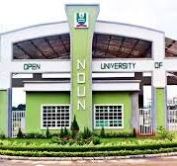

Plot 91, Cadastral Zone, Nnamdi Azikiwe Expressway, Jabi, Abuja
www.nouonline.nou.edu.ng

SAY NO TO SERVICE FAILURE

WHAT IS NOUN?
- It is not a part-time university
- It is not for college dropouts
- It is not for lazy students
- It is not a university where “ANYTHING GOES”
- It is a university for those who seek knowledge



